Felix Kiprono Bett

**QUESTION ONE (1)**

**What are the total sums of freights of ship cities that have orders from 2 or more customers?**

SELECT ShipCity, SUM(Freight) AS 'Total Freights',

COUNT(DISTINCT(CustomerId)) AS 'No. of Customers'

FROM 'Order'

GROUP BY 1

HAVING COUNT(DISTINCT(CustomerId)) >= 2;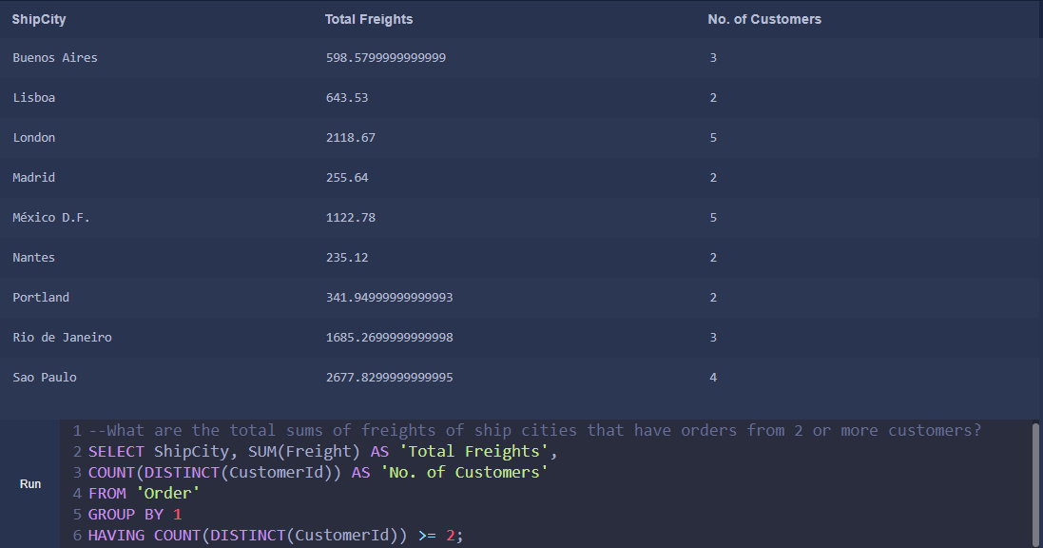

**QUESTION TWO (2)**

**Generate a table of employees and the number of customers they handle.**

SELECT E.firstname || ' ' || E.lastname AS 'Employee Name',

COUNT(DISTINCT(O.CustomerId)) AS 'No. of Customers Handled'

FROM Employee AS E

JOIN ‘Order’ AS O ON E.Id = O.EmployeeId

GROUP BY 1;

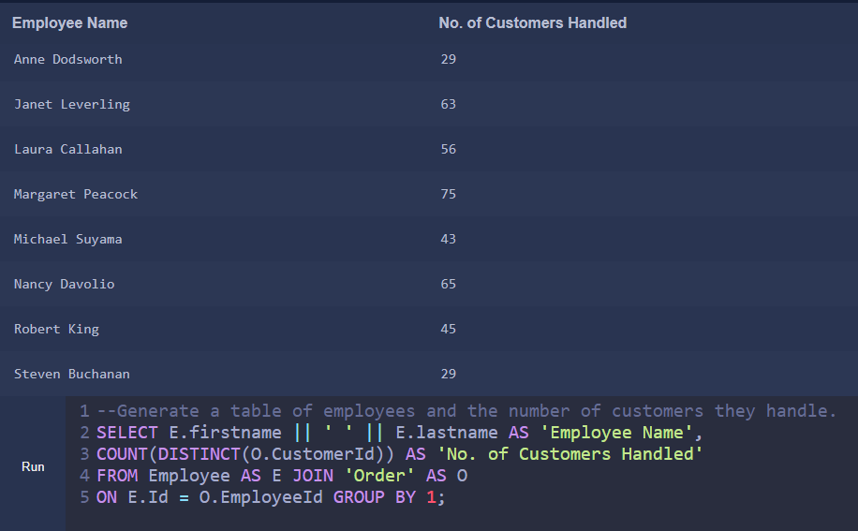

**QUESTION THREE (3)**

**How many orders were made each year?**

SELECT (substr(orderdate,1,4)) as Year,

COUNT(substr(orderdate,1,4)) as 'No. of Orders Made'

FROM 'order'

GROUP BY Year;

**QUESTION FOUR (4)**

**What quantity of the product ‘Chang’ was shipped in 2014?**

SELECT P.ProductName, SUM(OD.Quantity) AS 'Quantity Shipped in 2014'

FROM 'Order' O

LEFT JOIN OrderDetail AS OD

ON O.Id = OD.OrderId

LEFT JOIN Product AS P

ON OD.ProductId = P.Id

WHERE strftime('%Y', OrderDate) = '2014' AND P.ProductName = 'Chang'

GROUP BY 1;

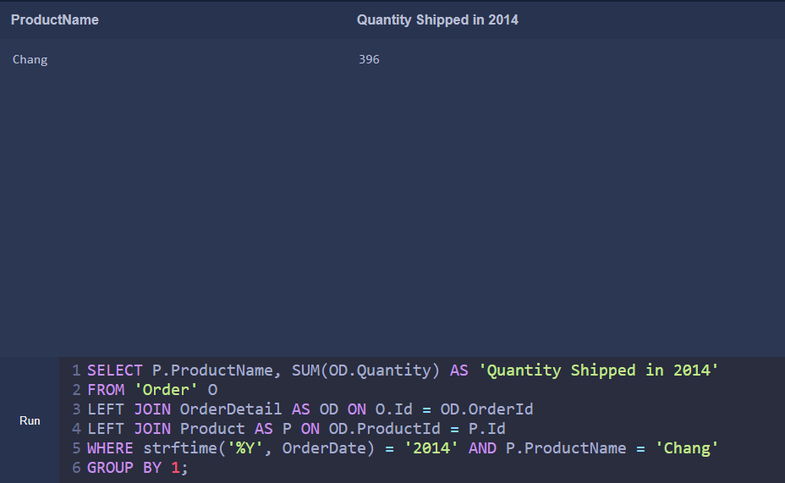

**QUESTION FIVE (5)**

**What are the revenues per supplier in 2013 before and after discount applied? Show both values in a single table.**

SELECT S.CompanyName AS Supplier,

SUM(OD.UnitPrice * OD.Quantity) AS 'Revenue Before Discount',

SUM((OD.UnitPrice * OD.Quantity)*(1 - OD.Discount)) AS 'Revenue After Discount'

FROM OrderDetail AS OD

LEFT JOIN 'Order' O ON OD.OrderId = O.Id

LEFT JOIN Product P ON OD.ProductId = P.Id

LEFT JOIN Supplier S ON P.SupplierId = S.Id

WHERE strftime('%Y', O.OrderDate) = '2013'

GROUP BY 1

ORDER BY 2 DESC;

